**Findings from the survey of older people in York**

**Summer 2017**

**CONTENTS**

**Summary 3**

**Introduction 4**

**Questions Asked and Survey Responses 5**

**Conclusions 36**

**Recommendations 36**

**Summary**

The Older People’s Survey was carried out during the summer of 2017 and contained a wide range of questions considered to be of interest to older people in the city of York, covering topics such as getting information and advice, their health, what they felt about their local area and planning for the future.

Around 900 people responded to the survey. They were completed by a demographically diverse group, covering those from ethnic minorities (although there were very few people of non-white ethnic origin responding to the survey), those under the age of 50, those over the age of 90, those saying they still worked and of various sexual orientations. Respondents from all areas of the city contributed, with them being fairly equally distributed in the areas covered by each of the city’s three Local Area Teams.

The most positive answers tended to be from the younger age groups (those under the age of 60) and from married people. The most negative responses tended to be from those described themselves as “widowed”, and from those aged 90 or over. Neither of these findings could be described as particularly surprising, but it does suggest that more needs to be done to help these groups.

More detailed information about the responses is listed in the “Questions Asked and Survey Responses” section. However, an overall summary would be that, on the whole, older people do not always find it easy to find information; they are quite sociable; they generally feel safe; their health is reasonably good; they feel public transport is good in York but could be improved; they do not feel particularly well-off financially; and that they need might need help with planning for the future.

**Introduction**

A meeting of the York Health and Wellbeing Board (YHWBB) held on 20 July 2016 heard a request to support the carrying out of a survey of older people, similar to the one that was carried out in 2008. The YHWBB agreed to this and work commenced through a steering group in October 2016. The steering group had representatives from a number of organisations which exist to help older people in the city: York Older People’s Assembly, Age UK York, Healthwatch York, York Community and Voluntary Service, North Yorkshire Police, the Vale of York Clinical Commissioning Group, York Hospital Trust and City of York Council.

The purpose of the survey was to discover what issues older people find important in York, and to identify what helps to keep them well and independent. The survey results were intended to be of use to local agencies when planning services in order that these could focus more on supporting good health and helping to keep people happy and healthy for longer. The survey was divided into nine sections, in order to obtain information about the various issues considered to be of most relevance to older people:

* Getting information and advice
* Social Life
* Health
* Independence
* Local community / area
* Transport
* Finances
* Planning for the future
* Demographic information about the respondent

The survey was distributed in May / June 2017 and data entry and initial analysis was conducted during July / August 2017. The survey was available to complete online and partner agencies distributed paper copies to their membership lists. The survey was also available in Braille, large print and audio format.

The survey comprised of 71 questions across the various topics. Most of the questions were of the “multiple choice” variety, with some of the questions being “free text” responses.

In total, 912 completed surveys were returned – 142 were online and 770 were paper submissions.

The analysis which follows contains details of the overall response to each question, along with some further commentary where appropriate about the difference in responses between men and women, the various age bands of respondents and the “marital status” of respondents. Describing differences by ethnic origin, as could occur in other local authorities, is not feasible in York because of the very low numbers of people describing themselves as being from an ethnic minority background (see Q61). As postcode information was given by most respondents (see Q69) it could have been possible to analyse information by ward but the numbers of people living in some wards responding were quite small. We have therefore looked at the answers by Local Area Team, and where there are differences we have reported these.

**Questions Asked and Survey Responses**

Percentages and proportions mentioned in the answers below are, unless otherwise stated, always given as a percentage/proportion of all those who gave a response to the question, rather than of all surveyed (912 people). It is assumed – as is standard statistical practice - that those people who did not response to a question would answer in broadly the same manner as those who did.

**Getting Information and Advice**

**Q1 – Where do you get information about activities, events and services in your local area?**

Respondents were given a range of options as to where they receive information – and were allowed to cite more than one option - and could suggest other sources if none of them applied. The most commonly cited sources were local newspapers and friends (both cited by over half of those asked), followed by the internet, community newspapers, radio and television. From this, it would seem that local information is of high importance to older people.

**Q2 – How do you prefer to receive information?**

Again, respondents were given a range of options as to how they prefer to receive their information, with more than one allowed to be chosen. Almost two-thirds said that they prefer to be contacted by post. Around one-third of respondents said that they would be happy to receive information in a face-to-face manner. More recent information communication methods (email, social media, text messaging) were cited by respondents but in lower numbers.

**Q3 – What format do you prefer information to be in?**

This question asks whether respondents want information to be in print, large print, audio or Braille – which can also be used as a proxy for hearing or sight issues. Almost three-quarters of the respondents said that print would be their preferred format, about one-fifth said large print, and only 4% said either audio or Braille.

**Q4 – Are there any areas where you think there is a lack of information in York?**

Respondents were given a list of areas that it was perceived they might require information about (local social groups, health services, adult care services, housing and so on) and were asked to tick any that applied. The most commonly cited area that there was thought to be a lack of information was adult care services, cited by around one-fifth of respondents. The next most often cited areas were transport, local social groups, health services, support groups, financial / benefits advice and leisure activities. It is notable that information about access to statutory services (adult care, transport and health) was thought to be lacking by some older people.

**Social Life**

**Q5 – Are you a member of any social groups?**

Respondents to this question were allowed to give a “Yes/No” answer, with those giving a “Yes” answer being free to state what their social group is. Overall, just over half (55%) of those giving a response said that they were a member of a social group. There were no major differences discovered amongst the various age groups, both sexes and the “marital status” of respondents. A wide range of answers were given, with local church groups, the Women’s’ Institute, University of the Third Age amongst frequent responses.

**Q6 – How often do you go out shopping?**

Five possible answers were given to this question, ranging from “Never” to “Every day”. The most common answer given was “Twice per week”, given by 45% of those answering this question. Only 12% said they never went out shopping, so the vast majority of older people go shopping, even if it’s less often than once per week. The ability to go shopping, perhaps unsurprisingly, does decline with age, however; only 5-6% of those in each of the “under 80” age bands said they never went shopping, but 40% of those aged 90 or over said they did not go shopping. Likewise, those who had been widowed were more likely to say they never went shopping (20%).



**Q7 – Do you require assistance with your shopping?**

People could respond “Yes” or “No” to this question, with a free text box given so those wanting to could elaborate on the nature of their assistance. Around a third of responders said they needed assistance. Women (39%) were much more likely than men (23%) to say they needed assistance, and assistance needed increased with age (61% of “over 90” responders said they needed help), compared with 19-22% of the younger age groups (under the age of 70). Encouragingly, many of the responders saying they needed help appeared to get it from other family members, typically a spouse, son or daughter. Those who lived in the city’s North area were more likely to need assistance (46% said they did) than other areas; those in the East of the city were less likely to need it (27% said they did).

**Q8 – How often do you go out socially?**

A range of potential answers to this question were available, from “never” to “at least every week” (in ascending order of frequency). Encouragingly, the most popular answer given was “at least every week”, mentioned by 41% of respondents. Only 15% of respondents said that they “never” went out socially. There is a bit of a decline with age in going out, with only 2% of those in the 50-59 age band saying they never went out, but this rose to 31% amongst those aged 90 or over. Those who had been widowed were also the least likely to go out every week and the most likely to never go out.



**Q9 – Thinking about how much contact you have, how would you describe your social situation?**

This question is analogous to one asked by CYC’s Adult Social Care User Survey, with four possible statement options to respondents; the least positive being “I have little contact with people and feel socially isolated”, and the most positive being “I have as much social contact as I would like”. Respondents were also allowed to state, in a free text box, if there was anything preventing them from having more social contact, if that applied. Encouragingly, 42% of respondents said they had “as much social contact as I like”, with a further 35% saying they had “adequate social contact”. Social contact did appear to decline with age, but not particularly significantly. Divorced people seemed to have the least social contact (only 65% gave a “positive” response, compared with 86% of married responders). “Transport” was the most frequently cited reason why people did not have more social contact, although that covers “not having a car” to “public transport not available”. Those in the city’s North area were much less likely to say they had “as much social contact as I like” (32% gave this response) than in other areas.

In terms of the impact of having inadequate social contact we looked at how people answered this questions in comparison to how people answered question 12 relating to their health status. Interestingly, those people that said they felt socially isolated or did not have as much social contact as they would like, were more likely to rate their health as poor or very poor than those that had adequate social contact.



**Q10 – Is there a difference in how much social contact you have depending on the season (e.g. less in winter?)**

Almost two-thirds (63%) of respondents said “No” to this question, although interestingly it was the “60-69” age group who were least likely to say no (55% of them did). There were no significant differences found between the sexes or the various “marital status” bands. Unsurprisingly, people tended to say they went out less in the winter than in the summer (a free text box was available for people to explain why if they say “Yes” to this question). Most of the reasons centred on the weather, fear of falling and some medical conditions feeling worse in winter.

**Q11 – What time of day would you choose to go out?**

There were three possible answers listed for this question – Morning, Afternoon and Evening, although people were allowed to choose one, two or all three options. Almost three-quarters (71%) said they would like to go out in the afternoon, with 64% saying the morning and only 31% in the evening. There is a sharp decline with age for evening-related activities: over 70% of those under 60 are happy to go out in the evening, which declines to just 17-18% in the two “over 80” age bands. Women (77%) say they are happy to go out in the afternoon, compared with just 63% of men. Widowed people are less happy to go out in the evening (just 17% said they would do).

**Health**

**Q12 – How would you rate your health in general?**

The possible answers given to respondents ranged from “Very poor” to “Very good”. Approximately four-fifths (81%) of respondents said that their health was at least “Fair” and it was only the very old (those aged 90 or over) and Single people who deviated from this proportion, and even then it was not particularly significant. Given the likelihood of people under-reporting their true health condition, this is an encouraging response. However, those in the North area were less likely to say that their health was “Very good” or “Good” (33% did, compared with 44% in the city as a whole).



**Q13 – In an average week, how many minutes of physical activity do you do?**

A free text box was provided for respondents to this question, and a wide variation of answers were given, ranging from 0 to 70 hours per week; some of the answers were in ranges (e.g. “10-15 hours per week”) and some indicated exercise without being specific about the time taken on the activity (e.g. “I play golf twice per week”). The percentage that reported doing the recommended levels of physical activity in a week (i.e. over 150 minutes per week) was 68%. This is similar to the proportion doing the recommended level of physical activity in the adult population in York (69.8%), which is higher than the England rate of 57%.

The median amount of time given by respondents was 180 minutes (3 hours), indicating around 26 minutes per day. As could be expected, there is a decline with age in physical activity – 300 minutes was the median answer given by those aged 60-69, but this was only 60 minutes amongst those aged 90 or over. Those who had been widowed were also less likely to be active for as long as other groups, the median for this group was 100 minutes.

**Q14 – In an average week, on how many days are you physically active?**

Again, a free text box was provided, but – as one might expect – the answers ranged only from 0 to 7. Half of respondents said that they were active on all 7 days each week, with a further 25% saying that they were active 4-6 days per week. There was little difference in the responses across the sexes or the various “marital status” groups, although it is noticeable that the “over 90s” choose either to be physically active each day (47% of them said they were) or not at all (33% said this, compared with just 11% overall).

**Q15 – Do you do any strength activity in a usual week? (This includes digging, carrying shopping, lifting weights, dancing, etc.)**

The options for this question were “Yes” and “No”. Just over half (54%) of people said that they did some strength activity in a usual week. Not surprisingly, this declined with age – 72% of those aged 50-59 did some, but only 24% of those aged 90 or over did. Those who were married (63% said “Yes”) were much more likely to do some than those who had been widowed (43% said “Yes”). There was little difference found between the sexes. National guidelines recommend that people should do strength based activity at least twice per week.

**Q16 – How much time do you spend sitting on an average day?**

Four choices were given to respondents for this question – “Less than 2 hours per day”, “3-4 hours per day”, “5-6 hours per day” or “Over 6 hours per day”. The most popular answer given was “3-4 hours per day”, cited by 38% of respondents, although it is perhaps a concern that 56% of respondents said that they sit for at least five hours per day. Not surprisingly, the amount of time spent sitting does appear to increase with age. Divorced and Single people appear to sit for the longest periods of time (68% of both groups said they sat for over 5 hours per day). Men and women sit for broadly similar amounts of time.



**Q17 – What do you do to keep yourself healthy?**

The answers given to this question were of a “free text” nature, so this is difficult to analyse quantitatively. The broad categories that answers fell into, along with some examples are shown in the Table 1 below.

**Q18 – What things would you like to do but don’t?**

Again, the answers to this question were of an open-ended nature, but interestingly it tended to be only the people who gave answers to Q17 who answered this question, suggesting that those who had an interest in their health and fitness were aware that they had limitations to what they could do, whereas those who did not answer Q17 perhaps had little interest in keeping themselves healthy. A lot of people cited being “more active” as answers, particularly going swimming. Some quotes from the survey are shown in Table 1 as an illustration to the type of comments that were made.

***Table 1 – what do you do to keep healthy?***

|  |  |
| --- | --- |
| **Diet** | **Eat healthily, diet with fresh fruit and vegetables, include nuts and fruit, eat properly, balanced diet.** |
| **Physical Exercise** | Gently exercise, keep doing physiotherapy exercises, swimming, walking, keep fit classes, cycling, upper body exercises, gardening, dog walking |
| **Mental Exercise** | Crosswords, play bridge, keep up with current affairs, sewing and knitting, book club, continuing in employment or volunteering |
| **Outdoor activities** | Walking (including dog walking, shopping, cycling) |
| **Indoor activities** | Knitting, housework, choir, cooking |
| **Socialising** | Keep socially active, looking after grandchildren |
| **Lifestyle** | Drinking alcohol to sensible limits, not smoking |
| **Sleep** | Sleep well, at least 7 hours sleep. |

**“I cannot find a professional and business women club, which I would like to join. I am hoping to become a member of some society later. I may re join the historical society”**

**“I am a carer and cannot engage in many social activities. I should like a 'mumsnet' for carers - not just a charity forum.”**

**“Friday club is only every other week. Something similar on another day would be helpful.”**

**“I would like to join clubs but meetings are often evenings and buses are few and far between later on and car parking in centre of York is not easy and I am increasingly reluctant to venture out especially at night.”**

**“Pub quiz at lunch times or early evenings.”**

**“Anything which helps me socialise. Everything seems aimed at younger generation.”**

**Q18 – What things would you like to do but don’t?**

Again, the answers to this question were of an open-ended nature, but interestingly it tended to be only the people who gave answers to Q17 who answered this question, suggesting that those who had an interest in their health and fitness were aware that they had limitations to what they could do, whereas those who did not answer Q17 perhaps had little interest in keeping themselves healthy. A lot of people cited being “more active” as answers, particularly going swimming. Some quotes from the survey are shown below as an illustration to the type of comments that were made.

**Q19 – What is preventing you from being able to do this?**

Free text boxes were also provided for this question, and thus quantitative analysis is difficult. Many of the respondents cited one or more existing health issues (back pain, poor eyesight, depression) as reasons why they were unable to stay healthy. Some mentioned affordability and others said that there were no groups in their local area that were able to assist with their issues.

**Q20 – Where would you usually go first if you wanted some information about a health matter?**

A range of options were given to respondents to choose (they could pick more than one). The most commonly given response was “GP surgery”, which was given by almost three-quarters (74%) of those surveyed. The graph below gives details of how often other possible answers were given. A free text box for “Other” responses was provided, but very few people gave an answer not in the existing range of options.



**Q21 – Other than going to a pharmacy to collect prescriptions or buy over the counter medicines, do you use any other services at your pharmacy?**

Various options were given to respondents to indicate which services at pharmacies they used (they could choose more than one if they wished). “General advice about health issues” was the most commonly chosen answer, given by 27% of respondents. The next most popular answers were “I am not aware of any other services my pharmacist offers” (selected by 25% of respondents), “Medicines use review (18%) and “Getting a vaccination” (15%). Very few people selected more than one answer.

**Q22a – Do you do any regular health monitoring of yourself at home? (Such as taking your blood pressure, monitoring blood sugars).**

Only a quarter of respondents indicated that they did regular health monitoring at home. There was little difference in the pattern of responses to this question by sex, age band or “Marital Status”.

**Q22b – If yes, do you feel confident doing this?**

Those answering “Yes” to Q22a were then invited to state a “level of confidence” in which they applied their health monitoring, with the options “Very”, “Fairly” or “Not very”. The majority of responders (57%) said they were “Very” confident, although this declined with age as this peaked at 68% amongst 70-79 year-olds and was only 32% amongst those aged 90 or over. Confidence amongst those widowed was lowest also (only 48% said they were “Very confident”). Men (67%) were more likely to answer “Very confident” than women (54%).

**Q23 - How would you feel about doing more monitoring of your health at home?**

People were given three options for this answer: “I would rather do this”, “I would be happy to do this for some things” and “I would not like to do this”. Perhaps not surprisingly, just over half (51%) of people responded that they “would be happy to do this for some things”. A further 37% said that they “would not like to do this” suggesting that they are happy to leave this to qualified professionals. Resistance to health monitoring was highest amongst widowed people (50%) and those aged 90 or over (64%). There was virtually no difference between the sexes in their responses. A free text box was also provided for people to explain their answer, and a wide range of answers were given that proved difficult to analyse quantitatively.

**Q24 – Do you feel that health professionals allow you to take control of your own health?**

Over three-quarters (78%) of respondents felt that health professionals allow them to control their own health, with little variation between the age groups. Single people felt this happened less (68% said “Yes” to this question), and women (80% said “Yes”) felt this happened more than men (74%).

**Independence**

**Q25 – Could you benefit from technology in the home that could support you as a carer?**

Just over three-fifths of those asked responded to this question, indicating that they may have been carers. As well as “Yes” and “No” responses, “Not Sure” was also given as an option. The majority (55%) said that they did not feel they could benefit from technology, with only 15% indicating that they could. Those over 90 were far more likely (25% of that group who responded) to say they would benefit, otherwise there was little difference between the various martial status groups, other age bands and between the sexes.

**Q26 – What things do you think are important in helping to increase peoples’ independence, helping them to live in their own homes for longer?**

A list of options was available to respondents, who could tick more than one option if they wished to. The most common response was “More contact with friends and family”, which was given by 53% of those surveyed. Other frequently-given responses (cited by between 44% and 49% of those surveyed) included “Access to information on support and services”, “Help with having your home adapted”, “More social activities held in the community” and “Support for people that care for a relative or friend”. A free text box was offered to those who wished to expand on their, or give a different, answer, but relatively few people completed it.



This question was asked in the previous 2008 York Older People’s Survey and it is interesting to see that there has been a shift to more people citing the importance of social contact.

***Table 2 - What keeps people indepent responses from 2008 survey and 2017 survey***

|  |  |  |
| --- | --- | --- |
| **Answer Choices** | **Responses 2017/2008** | |
| **More social activities held in the community** | 52% | 40% |
| **More contact with friends and family** | 62% | 43% |
| **Moving to a new home with care and support linked in** | 30% | 34% |
| **Support for people that care for a relative or friend** | 52% | 60% |
| **Help with the practicalities of running a home** | 50% | 70% |
| **Help with personal care** | 45% | 70% |
| **Access to information on support and services** | 58% | not asked |
| **Help with having your home adapted** | 56% | 73% |

**Q27 – What services should be more widely available to help people live independently?**

A range of potential services were offered to respondents, along with a free text box if they felt that none of those services covered what they needed; they were allowed to tick more than one box. Of those offered, the most popular choice was “Handy person services” (chosen by 54% of responders). There is a clear need for services to serve older people, as each of the 11 options was chosen by at least 37% of responders. The next most popular services sought were “Foot care / toenail cutting services”, “One point of contact to get information about help, advice and activities” and “Gardening services”. There were very few responses in the free text box.

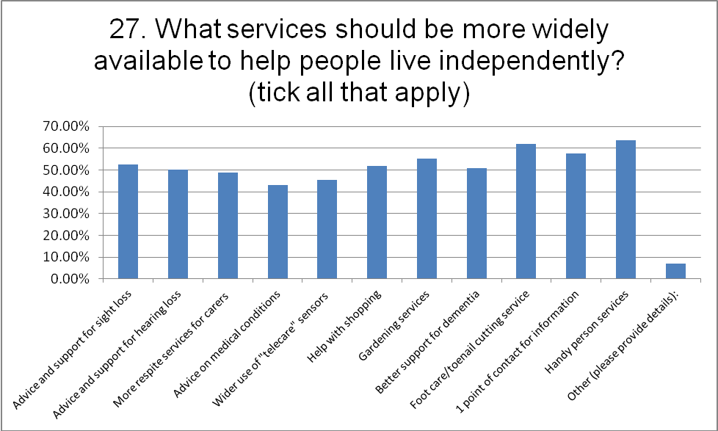

**Local Area**

**Q28 – Please list three positive things about where you live.**

As respondents to this question were given three free text boxes to answer this question, it is difficult to analyse quantitatively, but answers felt into three categories, covering connectedness (e.g. transport, local facilities like shops, health services, etc), the people (good neighbours, near friends and family), the environment (e.g. clean, safe, open spaces and parks). The image below provides an illustration of the kinds of issues raised, with those in larger print being said the most often.

***Figure 1 – positive things about where you live***

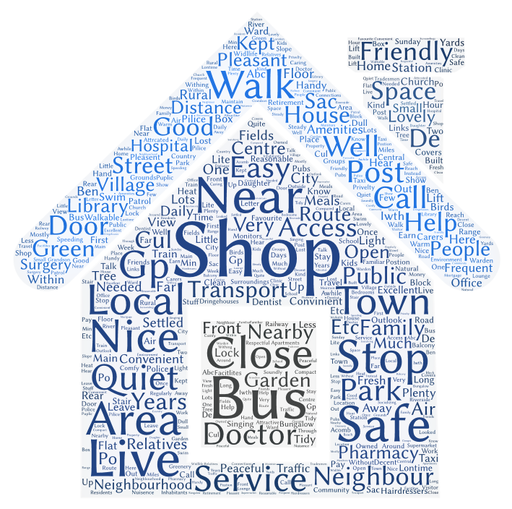

**Q29a – Do you do anything to help others in the city (e.g. neighbourhood watch, snow warden, etc.)**

Just over a quarter (27%) of those answering this question said that they did “something” to help others in York, although there was a fairly wide range of responses amongst the various groups. Only 19% of those widowed said they helped others, compared with 33% of married people. There was a decline with age, too: 44% of those aged under 70 said they helped, but only 10% of those aged 90 or over did. Men (31% said they helped) were more likely to do so than women (27%). People in the East of York were more likely to say they helped others (32% did) than in the North of York (22% did). A free text box was given for people to say what they did – volunteering was the most common answer.

**Q29b – If no (to Q29a), would you like to?**

Of those that answered this question, only 22% said they would like to help, which suggests that a lot of older people do not have the time, the ability or the inclination to assist others. There were some big differences amongst the population responding: 35% of the divorced and 31% of single people said they would like to help, as would the younger age groups (34% of those aged under 70). It is quite striking that women (27% said they would like to help) are over twice as likely as men to want to help (13%).

**Q30 – How could York city centre be improved?**

Respondents were asked to complete a free text box with their suggestions. A high proportion of those answering mentioned the provision of extra seating and / or toilet facilities. There were also comments about the provision for disabled people and the state of the pavements. Figure 2 provides an illustration of the comments made, with the most frequently said in larger print.

***Figure 2 – how could York City centre be improved?***

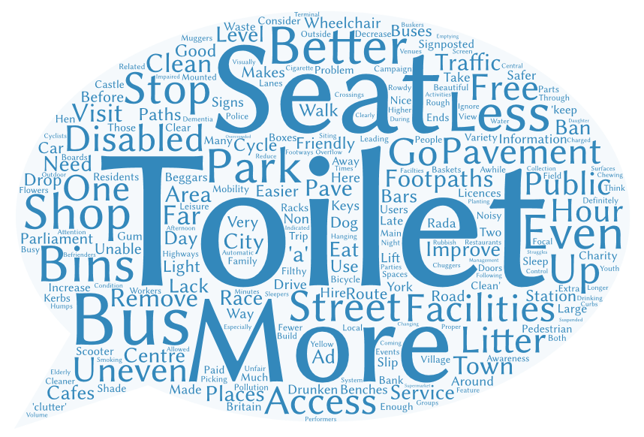

**Q31 – How safe do you feel in the area where you live?**

Encouragingly, 98% of those who responded to this question felt that their local area was either “completely safe” or “safe most of the time”. There were no real differences in this pattern by sex, age band or marital status. A free text box was offered for people to say why they felt unsafe (if they did), and most gave answers relating to their own fear of crime. Those that answered that they did not feel safe were spread geographically across the City and not clustered in one area.



**Q32 – How safe do you feel in your own home?**

Around three-fifths (62%) of those responding to this question said that they felt safe in their own home. There was little difference between the various age bands and marital status groups but men (67%) said they felt safer in their own home than women (60%). There was a free text box offered to people to say why they might have felt unsafe but relatively few people gave opinions. Again those that answered that they did not feel safe were not clustered in one area.

**Q33 – Are there any particular issues that you worry about in your home or neighbourhood?**

A range of issues that were considered to be of interest to older people were listed, and respondents were allowed to choose more than one option if they wished. The most popular answers given were “Fear of falling” (cited by 31% of those surveyed), “Road traffic”, “Theft / burglary” and “Fraud / scams”. A free text box was offered to people to list other issues but not many people gave answers.

**Q34 – Do you feel confident that you know how to protect yourself from fraud and/or scams?**

Over two-thirds (69%) of those responding to this question said that they “knew how to protect themselves” from fraud / scams, although the percentage of single people saying they did was somewhat lower (60%). There is also something of a decline with age, with 81% of those under 70 responding that they could protect themselves, compared with only 59% of those aged 90 or over. There was little difference between the sexes.

**Q35 – Do you feel that the police understand your needs and concerns?**

Just under four-fifths (80%) of those responding said “Yes” to this question, so there is confidence amongst older people that North Yorkshire Police take their needs and concerns seriously. There was little difference from this overall proportion amongst the various age groups, marital status groups and between men and women. A free text box was given for people who answered “No” to state why: many of those who answered mentioned that the police were rarely seen in their local area. There was however, no one area of the City where this seemed to be more of an issue than in others.

**Q36 – Are you confident the police would respond appropriately if you reported a crime or incident?**

Approximately three-quarters (78%) said “Yes” as a response here. Interestingly, there was more faith in the police amongst those aged 90 or over (84% said “Yes”) than amongst those aged 50-59 (65% said “Yes”), and more faith was expressed by women (80% said “Yes”) than men (72% said “Yes”). There was a free text box provided for those who said “No” to this question to explain further, and many of them expressed uncertainty that they would respond in a timely manner.

**Q37 – How do you feel about your local neighbourhood?**

This question asked whether the respondent knew “lots of” or “a few” people as a proxy for their satisfaction with their local neighbourhood. Just over half the respondents said that they knew “a few people”, with 40% saying they knew “lots” and 10% saying “I just live there”. Single people (19%) and those under 50 (18%) were more likely than others to say “I just live there”. The very elderly, those aged 90 or over (64%) were most likely to say that they “knew only a few people”. There was no geographic clustering of people that answered “I just live there”.

**Q38 – How long have you lived in this area?**

Respondents to this question were allowed to give a “free text” answer which has been translated into years of residence. The range of responses was, unsurprisingly, quite wide, from 6 weeks to 87 years. The median answer given by respondents (see graph on next page) was 25 years, although this varied amongst the groups – for single people it was 16 years and for widowed people it was 30 years. An interesting discovery was that the median for women (22 years) was less than for men (30 years), suggesting that women were more likely to have settled in their current area later than men did.

**Q39 – Is there anyone to whom you could go and call on?**

Encouragingly, the vast majority (87%) of those responding to this question said that they had someone they could call on, and, interestingly, this appeared to increase with age – only 73% of the under-60s said they could call on someone, compared with 89% of those aged 80 or over.

**Transport**

**Q40 – What is your most frequent form of transport?**

People were given a range of transport modes to choose from, and could choose more than one. The mode of transport chosen by most respondents was the bus (53% ticked this box). The next most common transport modes were to travel by car (selected by 49%), walking (chosen by 43%) and a taxi (picked by 27%). Car use declined with age: 70% of those under 60 drove, compared with only 33% of those over 90. Another interesting finding is that 71% of married people said they drove, but only 37% of divorced, single and widowed people drove. Bus use is highest amongst 70-79 year-olds (72% of them said they use them), and lowest amongst widowed people (only 46% used them).

**Q41 – Do you have use of a car?**

Just over half (56%) of those responding to this question said they had use of a car. There was a decline with age in use, with 85% of those under 60 saying they had use of one, declining to just 32% of those aged 90 or over. Almost half (47%) of those aged 80-89 used a car. Overwhelmingly, married people (81%) who said they used a car, rather than widowed or single people (both 36%) and divorced people (just 29%) who used one; married people are more likely to have access to the finances necessary to run a car. Men (65%) were more likely than women (52%) to say they used a car.

**Q42 – Do you have a Disabled Person’s Blue Badge?**

Just over a third (35%) of those responding to this question said that they had a Blue Badge, and there was some variation amongst the groups: 47% of those widowed said they had one, compared with just 26% of single people; 62% of those aged 90 or over said they had one; however, just 18% of those under 60 did and this percentage declined amongst the younger age bands. The rate of those saying they had a Blue Badge was much higher in the North of the city (47%) and lower in the East of it (29%).

**Q43 – How satisfied are you with the public transport in York?**

The majority of those responding say they are at least “mostly” satisfied with public transport in York (83% said “Very” or “Mostly” satisfied). The least satisfied group were those aged 50-59, where only 68% of those responding gave one of these answers. There was little variation between the sexes or the various “marital status” groups. A free text box was given for comments about public transport – many of the comments were positive about the frequency of buses but there were many negative comments about the lack of services in the evening.



**Q44 – Are there any other barriers to getting about in York (e.g. health condition, car parking facilities, lack of seating, lack of public toilets etc.)?**

This was offered as a free text box to respondents, and thus is difficult to analyse quantitatively, but many of the responses made references to the lack of seating, car parking (references were made to how expensive it is) and public toilets in the city centre, and many cited having a health condition as a barrier.

**Finances**

**Q45 – Do you work?**

Given the audience for this survey, it is little surprise to discover that only 93 (10%) of the respondents said they worked, either full-time or part-time, and 85% of those were under the age of 70. The majority (66%) of those under the age of 60 said they worked to some degree, but only 20% of those aged between 60 and 69 worked. Women (72% of those working) were much more likely to be working part-time than men (52% of those working). Of married people, 16% said they worked, compared with just 1% of widowed people. The finding that two-thirds of those working were doing so on a part-time basis was generally commonly found by age and marital status.

Respondents could also say if they were retired or volunteered. The highest percentage of retirees were widowed people (72%) compared to 65% in the group as a whole, which is not that surprising. One in every ten of those surveyed said they volunteered, with the highest rates of volunteering found amongst 60-69 year-olds (19% said they did) and divorced people (17% said they did).

**Q46 – How do you feel about your financial situation?**

A range of responses were offered to this question, from having “no worries” about money to “constantly” worrying about it. The most frequent answer given was “I feel reasonably secure about it” (see graph on next page), with 38% of those responding giving this. Just 12% said that they “just about manage” or they “constantly worried” about it, but this was higher amongst divorced people (22%) and single people (21%). There was an increase in financial security with increasing age, with younger people tending to worry more about it than the very elderly. There was no difference found between men and women.



**Q47 – What is your total weekly income before paying bills (including benefits)?**

Those surveyed were given a range of income bands – over £400, between £201 and £400, between £81 and £200, £80 or less, and they were also allowed to state that they would “rather not say” what it was; this proved to be the most frequently cited answer (given by 42% of respondents). Of those that gave an income band, the most frequent one was “between £81 and £200” (given by 22% of those responding). Not surprisingly, incomes appeared to be highest amongst married people (18% of them said they had over £400 of income per week, compared to 12% of the whole group) and lowest amongst single people (4% had income of over £400 per week). The percentage saying they had over £400 per week declined with age, and men (18%) were much more likely than women (10%) to earn the highest amounts.

**Q48 – Do you claim any benefits? If so, what are they?**

A list of benefits was provided to respondents, along with a free text box for people to say if they received any others, and people were allowed to select more than one option. A council tax reduction was the most frequently cited benefit that people claimed – stated by 25% of those replying (particularly in the North of the city – 36% of responders said they claimed it). Attendance allowance was claimed by one-sixth of those surveyed. Attendance allowance was the most frequently “other” benefit mentioned by respondents (17% did so, but this rose to 26% amongst those resident in the city’s North area).

**Q49 – Where would you go for advice about benefits?**

Those surveyed were given a range of options as to how they could find advice about benefits, and were given the option to tick more than one box if they needed to. They could also say if they did not know how to go about finding advice about benefits. Around one-third of respondents said that they would contact Age UK; the main other providers of advice mentioned were “Friends / family” and the Citizen’s Advice Bureau, which were mentioned by around one-quarter of respondents. Only 10% of respondents said that they did not know how to access advice about claiming benefits, so it would seem that knowledge about how to claim benefits is pretty widespread amongst older people.

**Q50 – Are you reluctant to claim benefits?**

Most people appear to be quite happy to claim benefits, with 69% of those responding saying “No” to this question. There were few differences discovered in this pattern of response amongst the various age bands, marital status groups or between sexes. A free text box was provided for people to add further comments, and some of the responses cited that there were “too proud”, or similar, to claim them.

**Planning for the future**

**Q51 – Have you moved house to better meet your needs in older age?**

Only one-third of those responding to this question said they had moved house. This did vary amongst the age bands, with only 20% of those under 60 saying they had, compared with 43% of those aged 90 or over. Women (35% saying they had moved) were likely to have moved than men (27%). There was little variation by “marital status” in responses to this question.

**Q52 – Have you had adaptations or aids fitted in your home?**

Just over half (51%) of those responding to this question said that they had fitted adaptations or aids. Those who had been widowed were far more likely to have done so (70% of them had) than other groups; only 40% of those who were married had done. Perhaps unsurprisingly, the likelihood of having adaptations / aids increased with age, with 84% of those aged 90 or over having done so, compared with just 23% of those aged under 60. There was little difference in response between the sexes. There was a much higher percentage answering that they had in the North of the city (63% of those responding said they had adaptations / aids) and a lower percentage in the city’s East (40% gave this response).

**Q53 – Have you made a will?**

The vast majority (85%) of those answering this question said that they had made a will, with widowed people being the most likely to have done so (91% of them did), and single people being the least likely (71% of them said they had). Likewise the percentage having done so rose with increasing age, with only 61% of those under 60 having made a will, compared with 97% of those aged 90 or over. There was no difference in the percentages reported between the sexes.

**Q54 – Have you made an advanced directive?**

The majority of people (59% of those responding) said that they had not made one, although the next most popular answer was “I don’t know what that is”, cited by 24%. Widowed people were most likely to have made one (24% compared to 17% of all respondents); married people least likely (70% of all respondents). As could be expected, the likelihood of people making one increased with age, with only 5% of those aged under 60 having made one, compared with 24% of those aged 80 or over; interestingly those aged 90 or over were most likely to say they did not know what an advanced directive was. The pattern of answers given by men and women were broadly similar.

**Q55 – Have you organised power of attorney?**

The answers were broadly evenly split between “Yes” (49%) and “No” (48%) with 3% of responders saying that they “Did not know” if they had organised it. Those who had been widowed were far more likely to have organised it (67% of that group had) than divorced (37% of that group had) or single (38% of that group had) people. Unsurprisingly, the likelihood of a “Yes” response increased with age, with only 20% of those under 60 saying they had organised it compared with 74% of those aged 90 or over. There was no significant difference in the response between the sexes.

**Q56 – Have you talked to family / friends about your wishes if you become unwell?**

Almost two-thirds (63%) of responders said that they had talked to family / friends about what to do in this instance, but this masks considerable variation within the groups. Only 43% of single people said “Yes” to this question, compared with 77% of widowed people. As with many questions in this survey, the likelihood of a “Yes” answer increased with age, with just 39% of those aged under 60 saying so, compared with 78% of those aged 90 or over. Women (64%) were more likely to say “Yes” to this question than men (57%).

**Demographics**

**Q57 – Are you male / female or do you prefer not to say?**

Of the 912 responses received, 577 (63%) were from females, 236 (26%) were from males, 3 (0.3%) ticked the “Prefer Not to Say” box and 96 (11%) did not give an answer. This pattern of responses is broadly in line with what could be expected, given the demographics of older people in the city which show that women outnumber men by almost a 2:1 ratio amongst those aged 80 or over.

**Q58 – What is your age?**

Although the survey was aimed at those of an “older age”, there is no clear definition of what age that could be considered as such. The survey was distributed by a number of organisations working with older people in the city, but that does not mean that it was exclusively answered by those that would normally be thought of as being of an “old age”. The ages were grouped into bands: 17 (2%) of replies came from those under the age of 50, 50 (5%) were from those aged 50-59, 177 (19%) were from those aged 60-69, 210 (23%) were from those aged 70-79, 267 (29%) were from those aged 80-89 and 100 (11%) were from those aged 90 or over. 91 (10%) of those replying did not have their age recorded. People responding in the North of the city tended to be older (81% were aged 70 or over, compared with 69% in the East and West of the city).

**Q59 – What is your marital status?**

Six choices were given to respondents to state their marital status. The most frequent answer given was “Married”, stated by 347 (38%) respondents. The next biggest group was “Widowed”, stated by 274 (30%). There were 90 (10%) single and 86 (9%) divorced people who participated. Co-habiters and those in civil partnerships provided answers to 25 (3%) of the surveys. No answer to this question was given by 90 (10%) responders. As the number of co-habiters and those in civil partnerships is low, they have been excluded from the analysis given above because the percentages for them tended to be more extreme from those given by other groups.

**Q60 – What sexual orientation do you identify as?**

Unsurprisingly, given the answers to Q59, 738 (95%) of the 777 responders to this question said they were “Straight / heterosexual”. 22 (3%) of the responders preferred not to say their sexual orientation, whilst 9 (1%) said they were “Lesbian, gay / homosexual”. The other 8 (1%) said they were “Bisexual, Not sure” or “Other”. Some 135 (15%) of those surveyed chose not to answer this question, which is a higher rate of non-response than for other questions, suggesting that the true rate of those who do not identify as “Straight / heterosexual” may be slightly higher than given here. People were invited, via a free text box, to add comments to this and most people gave comments that were analogous to “Straight / heterosexual”. A few found it intrusive.

**Q61 – What ethnic origin do you identify as?**

The Census categories for ethnic origin were used in the survey, and 794 (87%) people responded with an answer of some description. Those who did were overwhelmingly “White British”: 767 (97%) gave this answer, with a further 15 (2%) stating they were “White Other” and 6 (1%) “White Irish”. Only six responses were received from those indicating a “non-white” ethnic origin. There were 118 surveys returned with no ethnic origin stated. This explains why there are no breakdowns to any of the questions above by ethnic origin, the “non-white” group being too small to conduct any meaningful analysis.

**Q62 – Do you have any long-term health conditions (e.g. diabetes, heart disease, depression, sight / hearing loss)?**

Given the population surveyed it was not surprising to discover that 76% of those responding said they had a long-term health condition. The highest rates of those saying “Yes” to this question were to be found amongst widowed (84%) and divorced (83%) people; married (70%) were less likely to have said “Yes”. As with so many health-related questions, the likelihood of a “Yes” answer here increased with age, with just 49% of under 60s giving this answer compared with 88% of those aged 90 or over. Men (83%) were more likely to have had one than women (73%).

**Q63 – How many long-term health conditions do you have?**

This follows on from Q62 and most of those saying “Yes” are likely to have answered it. An open-ended response was offered; the answers ranged from 0 to 16, with the most frequently given (and median) answer being 2. Only 7% of responders said they had more than four long-term health conditions. Only the relatively young (those aged under 60) and married people deviated significantly from this pattern of response; they were more likely to have had only have one long-term health condition. There were some interesting geographical variations found; although the median in all three areas was 2, in the East the most frequently given answer was 1, in the North it was 2 and in the West it was 3.

**Q64 – Do you provide regular care for a relative or friend?**

Less than one in every five (18%) responses to this question were “Yes”, although there were significant variations amongst the groups. Of married people, 32% said that they provided regular care, but just 3% of widowed people did so. The ability of people to provide care appears to decline with age: 33% of the under-60s mentioned that they helped someone else, but this was just 6% amongst those aged 90 or over. There was no difference reported between the sexes as to whether they cared for someone else or not. There was also a box provided for those who do provide regular care to state how long they cared for someone on average per week. Although relatively few people gave an answer, the most common answer was that they cared for someone “constantly”.

**Q65 – What type of accommodation do you live in?**

Of those that responded to this question, 80% of them said that they lived in accommodation that they “owned”, 11% said that they rented (either from the council or privately), and the remainder were in a housing association property or in sheltered accommodation / extra care housing. Married people were most likely to “own” their property (90% said they did), with single people being least likely (only 52% reported they did). Single people were also most likely to be renting from the council (20% of those did) and be in sheltered accommodation / extra care housing (11% said they did). Age appeared to make little difference to the type of accommodation lived in, and there was no real difference between the sexes either.

**Q66 – Do you live alone, with other family, with a spouse / partner or with other people?**

Almost exactly half of those responding to this question said that they lived “Alone”, with a further 43% living with a spouse/partner. (It is possible that some of those responding may live in some form of residential accommodation and thus may live in a building occupied by other people, but this is how they chose to consider themselves). The vast majority (89%) of those describing themselves as “divorced”, “single” or “widowed” lived alone. The likelihood of living alone appears to increase with age: 16% of those under 60 lived alone, compared with 81% of those aged 90 or over; correspondingly the likelihood of living with a spouse/partner similarly declines with age (64% amongst the under-60s; 11% amongst those aged 90 or over). Women are much more likely than men to live on their own (57% compared with 33%); men are much more likely to live with a spouse/partner (62% compared with 36% of women). The pattern is slightly different in the North of the city, where 59% lived alone and only 36% with a spouse/partner.



**Q67 – Do you have children near by who would be able and willing to support you if needed?**

The responses to this question were almost exactly split between “Yes” and “No” responses. Widowed people were the most likely group to say “Yes” (62% did), single people the most likely group to say “No” (89% did). The pattern amongst the various age groups was not noticeable different from the overall pattern, and there was little difference found between men and women in the likelihood of children living nearby.

**Q68 – Are you linked to any kind of personal assistance alarm?**

Just over one-third (34%) of those responding to this question said they had a personal assistance alarm. There was considerable variation amongst the “marital status” groups, with 58% of those widowed saying that they had one, compared to just 15% of those who were married (but widowed people are more likely to live alone (see Q66)). Only those aged 90 or over (76% of them did) were more likely to answer “Yes” than “No” to this question, with comparatively few under the age of 70 seeming to have the need for one. Women (37% said “Yes”) were more likely than men (28% said “Yes”) to say they had one. People in the North of the city were more likely to have had an alarm (47% did) than elsewhere.

**Q69 – Your post code?**

The purpose of collecting the postcode would be to allow further analysis of these results by area to see whether there are any further differences in the analysis given above by local area level. The post code information was mapped to each of the city’s 21 wards (see map on next page). Of the 912 respondents, it was possible to match the post code, where it was given, to wards in 641 (70% of) instances. Approximately half of the respondents lived in six wards: Acomb, Fishergate, Haxby and Wiggington, Heworth, Holgate and Huntington and New Earswick. Every ward in the city had at least seven respondents to the survey. Although there was variation between the wards, there was a reasonably equal split of responses received amongst the city’s three Local Area Teams – see table below.

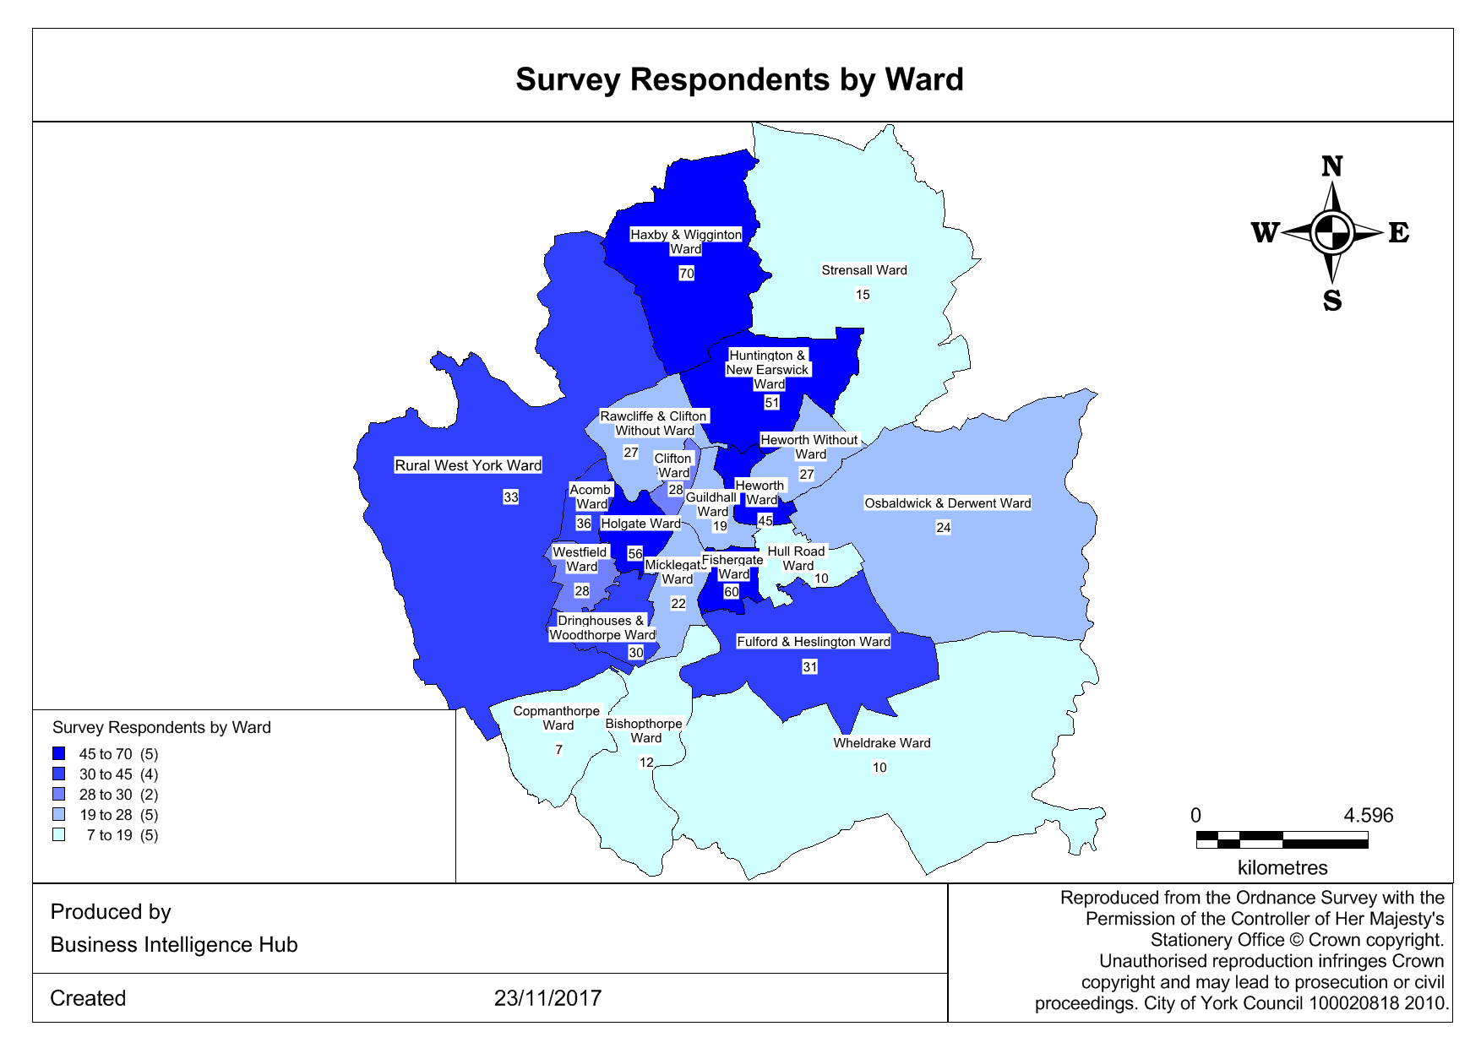



**Q70 – Do you use the internet?**

Just over half (53%) of respondents to the survey said they used the internet. Only 32% of widowed people said they used it, compared with 66% of married people. There was a decline in the likelihood of use with age: 89% of those under 60 said they used it, but just 16% of those aged 90 or over mentioned that they did. Men were more likely than women to have used it (60% compared to 51%). Internet use was a lot lower in the North of the city (only 41% said they used it) compared with the East (57% said they did).

**Q71 – Please use this space to add any further comments that you would like to make about how life could be improved in York.**

As this is a free text box, a rather eclectic range of comments resulted from those answering the question and thus cannot be quantitatively analysed.

**Conclusions**

The responses to this survey show that, although the experiences of older people living in York contain much that is positive – they generally feel safe, they are fairly sociable and are in good health – they tell us that there is a lot more that could be improved in the city: things such as providing seating in the city centre; making public transport more accessible; and making information and advice more easily available.

The most positive answers to questions were given by those who were relatively young and / or married; negative answers were mainly given by those who were elderly (particularly those aged 90 or over) or widowed (there is a big cross-over in these two groups), suggesting that there is more that could be done to help these groups of people.

There was little analysis that could be done looking at responses for ethnic minorities or for those of non-heterosexual sexual orientation because of the low numbers of people defining themselves as being part of these groups. This reflects, in part, the small population of those older people who are of non-white ethnic origin in the city.

Responses in different geographic areas (at Local Area Team level) have been given in the commentary where significant variances between these areas have been found; in many instances the differences between areas were insignificant. The responses would suggest that those older people living in the area covered by the North Local Area Team were less likely to feel positive about their lives. It would also be interesting to further cross-analyse responses between some of the questions given here, to see whether, as an example, those living alone are in poor health; or examining whether more could be done to encourage widowers to use the city’s buses.

**Recommendations**

The results from the survey have highlighted a number of issues that the partner agencies involved in the survey would like to make the following recommendations on:

**Information and advice**

* All organisations should have the means of providing information in written format.
* It is noted that the City of York Council are taking on board the difficulty in finding information on social care services through their Future Focus work programme. This will address a number of comments made by people within this survey and must continue.
* City of York Council and York Hospital Trust should take a full page advert in the local phone book setting out phone numbers, locations, and contact details for all services provided including for CYC, Sheltered Housing, Extra Care and Residential Schemes. Older people cited the entry for East Riding of Yorkshire Council as being more accessible.

**Social interaction**

* City of York Council should re-look at the provision of the park and ride service in the evening.
* The MS society should consider the findings from this study in the work they are leading on in the provision of community transport in York.
* Bus services in York should have audio visual information provided on board to increase accessibility in accordance with section 17 of the Bus Services Act.
* The Business Improvement District (BID) and CYC should take note of the results of the survey and consider how access to seating and toilets can be improved in the City Centre. For example such as Eastbourne Community Toilets <https://eastbournecommunitytoilets.accessibleeastbourne.net/about> and what can be done to improve the quality of pavements in the City Centre.
* The results of the survey should be shared with York’s Cultural Commissioning Consortium to help them in tailoring the cultural offer to York’s older residents.
* York CVS and partners, in delivering their volunteering strategy, should particularly consider how older men can be engaged in volunteering.

**Health**

* The City of York Yorwellbeing Service should develop information on physical activity guidelines for older people, particularly the importance of strength based activities and ensure older people have information on local clubs and activities.
* Community Pharmacy North Yorkshire should take note of the results of the survey and work with local pharmacies to promote their use and the range of services they offer, especially for older people.
* The CCG and City of York Council should consider how use of self monitoring can be promoted within primary care and Social Care.

**Independence**

* It is noted that the City of York Council have taken on board the results of this survey and increased capacity of the handyperson service. In addition it is noted that the gardening service has been sustained, minimising impact from required efficiencies and creating a more equitable service. This needs to be maintained.
* The toe nail cutting service is valued by older people. Partners across the City should work together to consider how access to toe cutting can be sustained.
* CYC should promote and market the Handyperson, Gardening and Toe nail cutting services and ensure the resources are available to meet demand.
* 30% of older people are concerned about falls. Partners should work together to consider how falls can be prevented and to ensure that consistent messages about falls prevention are given to older people.
* The findings within the survey on telecare have been passed onto the City of York’s Adult Commissioning Team for consideration when re-tendering the service. CYC, CCG and the York Hospital Trust should promote and market the services offered by the new provider in sustaining older people’s independence at home.

**Safety**

* The responses to safety in York were very positive and this good work needs to continue. As scams and frauds change older people need to be kept aware of these.